ID NUMBER: 22424271
MSC. APPLIED STATISTICS
DEPARTMENT OF STATISTICS AND ACTUARIAL SCIENCE
FIRST SEMESTER EXAMINATION 2025/2026
ASTA 607: COMPUTATIONAL STATISTICS

Question 1
1a. CODE
library(MASS)
?crabs

Output:
crabs {MASS} | R Documentation

Morphological Measurements on Leptograpsus Crabs

Description
The crabs data frame has 200 rows and 8 columns, describing 5 morphological measurements on 50 crabs each of two colour forms and both sexes, of the species Leptograpsus variegatus collected at Fremantle, W. Australia.

Usage
crabs

Format
This data frame contains the following columns:
sp
species - "B" or "O" for blue or orange.
sex
as it says.
index
index 1:50 within each of the four groups.
FL
frontal lobe size (mm).
RW
rear width (mm).
CL
carapace length (mm).
CW
carapace width (mm).
BD
body depth (mm).

1b. CODE
data(crabs) ##load the data set
head(crabs) ### to have a preview of the data

str(crabs)###structure of the data

OUTPUT
data(crabs) ##load the data set
> head(crabs) ### to have a preview of the data
sp sex index FL RW CL CW BD
1 B M 1 8.1 6.7 16.1 19.0 7.0
2 B M 2 8.8 7.7 18.1 20.8 7.4
3 B M 3 9.2 7.8 19.0 22.4 7.7
4 B M 4 9.6 7.9 20.1 23.1 8.2
5 B M 5 9.8 8.0 20.3 23.0 8.2
6 B M 6 10.8 9.0 23.0 26.5 9.8
> str(crabs)###structure of the data
'data.frame': 200 obs. of 8 variables:
$ sp : Factor w/ 2 levels "B","O": 1 1 1 1 1 1 1 1 1 1 ...
$ sex : Factor w/ 2 levels "F","M": 2 2 2 2 2 2 2 2 2 2 ...
$ index: int 1 2 3 4 5 6 7 8 9 10 ...
$ FL : num 8.1 8.8 9.2 9.6 9.8 10.8 11.1 11.6 11.8 11.8 ...
$ RW : num 6.7 7.7 7.8 7.9 8 9 9.9 9.1 9.6 10.5 ...
$ CL : num 16.1 18.1 19 20.1 20.3 23 23.8 24.5 24.2 25.2 ...
$ CW : num 19 20.8 22.4 23.1 23 26.5 27.1 28.4 27.8 29.3 ...
$ BD : num 7 7.4 7.7 8.2 8.2 9.8 9.8 10.4 9.7 10.3 ...

>

1c. CODE
### 1c
freq_table1<-table(crabs$sp)
freq_table1 ####frequency table for species

freq_table2<-table(crabs$sex)
freq_table2 ####frequency table for sex

freq_table<-table<-table(crabs$sp, crabs$sex)
freq_table ###frequency table for both species and sex

OUTPUT
freq_table1<-table(crabs$sp)
> freq_table1 ####frequency table for species

B O
100 100
>
> freq_table2<-table(crabs$sex)
> freq_table2 ####frequency table for sex

F M
100 100
>
> freq_table<-table<-table(crabs$sp, crabs$sex)
> freq_table ###frequency table for both species and sex

F M
B 50 50
O 50 50

>

1d.CODE
mosaicplot(crabs$sp~ crabs$sex , data = crabs, color = rainbow(2),
main="mosaic plot for sex and species")

OUTPUT
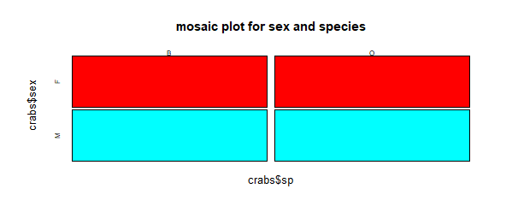
1e.
Yes, the data is balanced across the four groups and can be seen in the mosaic plot and frequency table.

2a
CODE
### 2a
par(mfrow = c(1, 2), mar = c(4,4,1,1))
boxplot(crabs$BD~crabs$sp, col = "blue",
main = "boxplot of bodydepth by species",
xlab= "species",
ylab="body depth")
boxplot(crabs$BD~crabs$sex, col= "red",
main = "boxplot of bodydepth by sex",
xlab= "sex",
ylab="body depth")

OUTPUT
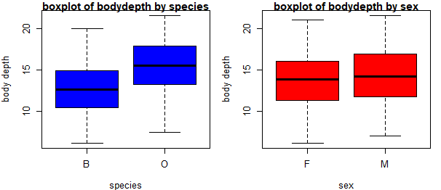

2b.
CODE
#### 2b
library(psych)
describeBy(x=crabs$BD, group = crabs$sp)
describeBy(x=crabs$BD, group= crabs$sex)
a<- list(describeBy(x=crabs$BD, group = crabs$sp),
describeBy(x=crabs$BD, group= crabs$sex))
a
print(a)

OUTPUT
Descriptive statistics by group
group: B
vars n mean sd median trimmed mad min max range skew kurtosis se
X1 1 100 12.58 3.07 12.6 12.55 3.26 6.1 20 13.9 0.07 -0.72 0.31
---------------------------------------------------------------------------------
group: O
vars n mean sd median trimmed mad min max range skew kurtosis se
X1 1 100 15.48 3.15 15.55 15.51 3.41 7.4 21.6 14.2 -0.08 -0.6 0.32

[[2]]

Descriptive statistics by group
group: F
vars n mean sd median trimmed mad min max range skew kurtosis se
X1 1 100 13.72 3.34 13.8 13.74 3.56 6.1 21.1 15 -0.02 -0.68 0.33
---------------------------------------------------------------------------------
group: M
vars n mean sd median trimmed mad min max range skew kurtosis se
X1 1 100 14.34 3.49 14.2 14.31 4 7 21.6 14.6 0.03 -0.62 0.35

>

Comment on 2b
There are no outliers as seen in the boxplot. Female has a widely spread out data as it has the largest range. Orange has the greatest average and median. Comparing the mean and median of each of them, it can be concluded that all the variables are almost symmetrically distributed. Blue has the least mean and median.

3a. CODE
par(mfrow = c(1, 3), mar = c(4,4,1,1))
hist(crabs$CL[crabs$sp == "B"],
main = "Histogram of Carapace length (B)",
xlab = "Carapace Length (mm)", col = "blue")

hist(crabs$CL[crabs$sp == "O"],
main = "Histogram of Carapace Length (O)",
xlab = "Carapace Length (cm)", col = "orange")
legend("topright", legend = c("B", "O"), fill = c("blue", "orange")

OUTPUT
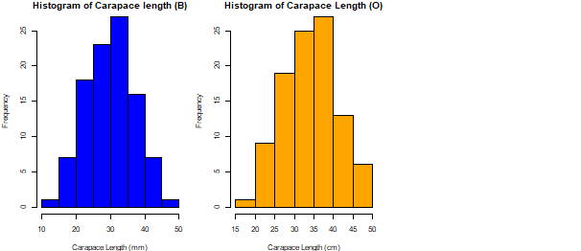

b. Comment
Though the shapes almost look the same, the blue species is almost evenly distributed(symmetric) which gives a skewness of almost 0 whilst the orange appears to be negatively skewed which gives a skewness <0.

4a. CODES
### mean of FL by Species
mean_O_FL <- mean(crabs$FL[crabs$sp == "O"])
mean_O_FL
mean_B_FL <- mean(crabs$FL[crabs$sp == "B"])
mean_B_FL

### mean of rw by Species
mean_O_RW <- mean(crabs$RW[crabs$sp == "O"])
mean_O_RW
mean_B_RW <- mean(crabs$RW[crabs$sp == "B"])
mean_B_RW

### mean of cl by Species
mean_O_CL <- mean(crabs$CL[crabs$sp == "O"])
mean_O_CL
mean_B_CL <- mean(crabs$CL[crabs$sp == "B"])
mean_B_CL

### mean of cw by Species
mean_O_CW <- mean(crabs$CW[crabs$sp == "O"])
mean_O_CW
mean_B_CW <- mean(crabs$CW[crabs$sp == "B"])
mean_B_CW

### mean of FL by Species
mean_O_BD <- mean(crabs$BD[crabs$sp == "O"])
mean_O_BD
mean_B_BD <- mean(crabs$BD[crabs$sp == "B"])
mean_B_BD

### mean of FL by sex
mean_F_FL <- mean(crabs$FL[crabs$sex == "F"])
mean_F_FL
mean_M_FL <- mean(crabs$FL[crabs$sex == "M"])
mean_M_FL

### mean of rw by Sex
mean_F_RW <- mean(crabs$RW[crabs$sex == "F"])
mean_F_RW
mean_M_RW <- mean(crabs$RW[crabs$sex == "M"])
mean_M_RW

### mean of cl by Sex
mean_F_CL <- mean(crabs$CL[crabs$sex == "F"])
mean_F_CL
mean_M_CL <- mean(crabs$CL[crabs$sex == "M"])
mean_M_CL

### mean of cw by Sex
mean_F_CW <- mean(crabs$CW[crabs$sex == "F"])
mean_F_CW
mean_M_CW <- mean(crabs$CW[crabs$sex == "M"])
mean_M_CW

### mean of FL by Sex
mean_F_BD <- mean(crabs$BD[crabs$sex == "F"])
mean_F_BD
mean_M_BD <- mean(crabs$BD[crabs$sex == "M"])
mean_M_BD

a<-list(mean_O_FL,mean_B_FL,mean_O_RW,mean_B_RW,mean_O_CL,mean_B_CL,mean_O_CW,mean_B_CW,
mean_O_BD,mean_B_BD,mean_F_FL,mean_M_FL,mean_F_RW,mean_M_RW,mean_F_CL,mean_M_CL,mean_F_CW,mean_M_CW,
mean_F_BD,mean_M_BD)

OUTPUT
> a
[[1]]
[1] 17.11

[[2]]
[1] 14.056

[[3]]
[1] 13.549

[[4]]
[1] 11.928

[[5]]
[1] 34.153

[[6]]
[1] 30.058

[[7]]
[1] 38.112

[[8]]
[1] 34.717

[[9]]
[1] 15.478

[[10]]
[1] 12.583

[[11]]
[1] 15.432

[[12]]
[1] 15.734

[[13]]
[1] 13.487

[[14]]
[1] 11.99

[[15]]
[1] 31.36

[[16]]
[1] 32.851

[[17]]
[1] 35.83

[[18]]
[1] 36.999

[[19]]
[1] 13.724

[[20]]
[1] 14.337

5a. CODE
pairs(crabs[,1:5], c("FL","RW","CL","CW","BD"))

OUTPUT

